**User Acceptance Testing(UAT) Template**

|  |  |
| --- | --- |
| Date |  |
| Team ID | LTVIP2025TMID42361 |
| Project Name | Househunt: Finding Your Perfect Rental  Home |
| Marks |  |

Project Overview:

### **📘 Project Overview: House Hunt – Finding Your Perfect Rental Home**

**Project Title:** House Hunt – Finding Your Perfect Rental Home  
 **Technology Stack:** MERN (MongoDB, Express.js, React.js, Node.js)  
 **Project Type:** Full-Stack Web Application

**Overview:** House Hunt is a modern rental home platform designed to simplify the process of finding and managing rental properties. It connects renters, property owners, and administrators on a single user-friendly system. The platform allows renters to easily search and book verified properties, while owners can list and manage their rentals with ease. Administrators oversee platform activity, ensuring all listings and users are genuine and trustworthy.

**Purpose:** To provide a centralized, secure, and efficient solution for the rental housing process by addressing key issues like unverified listings, lack of communication, and fragmented property data.

**Target Users:**

* **Renters:** Individuals looking for rental properties
* **Property Owners:** People who want to list and manage their rental homes
* **Admin:** Platform managers responsible for monitoring, approval, and system health

**Key Features:**

* User authentication and role-based dashboards
* Property listing, search, and booking functionalities
* Admin control for managing users and verifying listings
* Optional features: chat, reviews, wishlist, maps, and payment gateway

**Expected Outcome:** A fully functional, scalable web application that streamlines the rental process, improves trust between parties, and reduces time and effort for both renters and owners.

Test Cases:

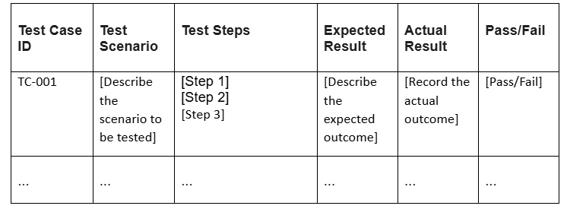

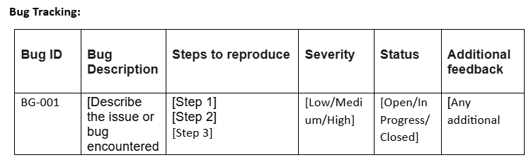

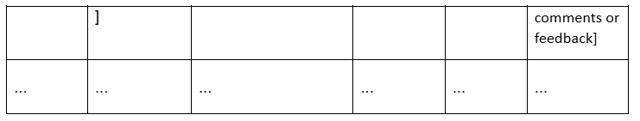

**Sign-off:**

Tester Name: [Name of Tester]

Date: [Date of Test Completion]

Signature: [Tester's Signature]

**Notes:**

* Ensure that all test cases cover both positive and negative scenarios.
* Encourage testers to provide detailed feedback, including any suggestions for improvement.
* Bug tracking should include details such as severity, status, and steps to reproduce.
* Obtain sign-off from both the project manager and product owner before proceeding with deployment.